Practice for topics 2 – 3 and 2 – 4: Plotting and explaining parametric paths, and converting to cartesian form
1). [C] Imagine you’re summarizing to your friend who missed class.
Tell them: What’s the Big Idea of parametric equations?
Write a simple example of a pair of parametric equations?
What does each one tell you?
What are they for when you put them together?
What’s the difference between parametric equations and a cartesian equation?

2). [P] Let $x\left(t\right)=1+\sqrt{t}$ and $y\left(t\right)=-(t+1)$ on the interval $0≤t≤4$
a). Plot (x, y) coordinates for points for $t=0, 1, and 4$. Sketch the parametric path (with little direction arrows)
b). Find the cartesian equation for the path travelled. What’s the domain restriction on the cartesian equation that corresponds to the path travelled?

3). [C/P] Make a single x-y graph for each set of parametric equations. Make a quick table if you really need to (say, plug in t = 0, 2 and 4), but your goal is just to capture the overall shape and think more intuitively about the x and y motions separately.
(a). $x\left(t\right)=t^{2}$, $y\left(t\right)=t$ on $t≥0$
(b). $x\left(t\right)=t$, $y\left(t\right)=t^{2}$ on $t≥0$
(c). Find the cartesian equation for a and b. Compare to your graphs.

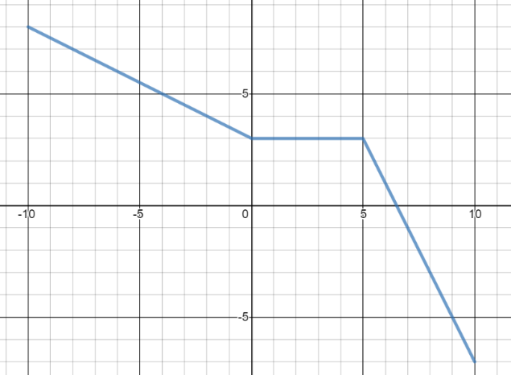
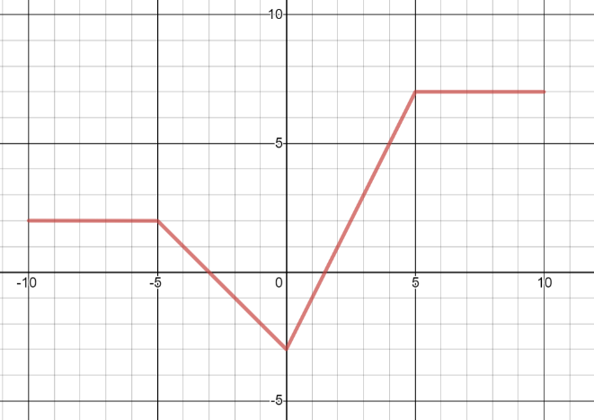
4). [C/P] Consider the graphs here of $x(t)$ and $y(t)$
$$y=x(t)$$
$$y=y(t)$$
$$x-coord$$
$$y-coord$$

$$time$$
$$time$$

- These graphs are only defined for $-10≤t≤10$. If we drew the path they define on the x-y plane, what would be the domain and range of the path?
- What are the point’s (x, y) coordinates when it reverses direction?
- Is the point ever in quadrant IV of the plane? (remember, quadrant IV is when x is positive and y is negative). If so, when?
- Sketch a graph of the path and motion, labelling 5 key points with their times and showing the direction of movement with arrows.




5). [C/P] Here are rough sketches for $x(t)$ and $y(t)$. Sketch the path of the motion they represent ( on the $y(x)$ graph to the right). Label the point at $t=0$ and add arrows to indicate direction of travel. ( you can think about t = 0, t = 1 and t =2 if you want).
$$x$$
$$y$$
$$t$$
$$t$$
$$x$$
$$y$$
$$x(t)$$
$$y(x)$$
$$y(t)$$

$$x$$
$$y$$
$$t=0$$
$$t=1$$
$$t=2$$
$$y(x)$$
6). [C/P] Here’s a motion along a path.
Sketch graphs for an $x(t)$ and $y(t)$ that would produce this path and movement.

7). [C] Consider $x\left(t\right)=\frac{1}{t^{2}+5}$ . At time t = 0 what’s the x coordinate? Your friend thinks that as time increases, the point will be moving to the right, because $t^{2}$ is positive.
Carefully explain what’s actually happening. How could they know for themselves that was true by looking/thinking about the equation?

8). Your friend changed the time bounds of some parametric equations: $x\left(t\right)=\frac{6}{t}+2$ and $y\left(t\right)=\sqrt{t}$ from $1≤t≤10$ to $0≤t≤30$.
Before: graph of $1≤t≤10$ | After: graph of $0≤t≤30$
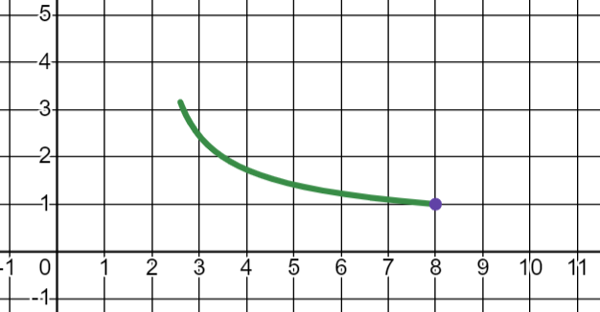 | 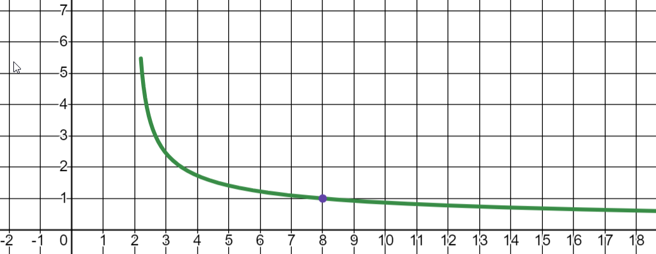
They say: “woah, why did changing the time to 30 make the graph run way off to the right like that?”
Decide if they’re right (that plotting time up to 30 is what’s responsible) and explain to them clearly how to think about what happened.

9). [P] Sketch the curve defined by each set of parametric equations are given here. Eliminate t to find a rectangular (cartesian) equation for each path.
  - $x(t)=t+2$, $y(t)=\sqrt{t}$ for $t≥0$
  - $x(t)=3^{t}$, $y(t)=1+3^{t}$ for $t≥0$
  - $x(t)=2^{t}$ $y(t)=\frac{1}{2^{t}}$ for $t≥0$
10). [C] In part c of the last problem you should have ended with the cartesian equation $y=\frac{1}{x}$ . However, the path travelled by $x\left(t\right)=2^{t}$ and $y\left(t\right)=\frac{1}{2^{t}}$ doesn’t cover the full curve $y=\frac{1}{x}$.
a. What domain restriction on the cartesian equation exists due to the time restriction $t≥0$ ?
b. If you sketched the path for $-∞<t<∞$ would there still be a domain restriction for the path? Explain.
c. What about equation b? If we allow $t>-∞$ where, exactly, is the point when $-∞<t<0$ (ie for negative times) ?
11). [P] If $x\left(t\right)=\sqrt[3]{t}-3$ and $y\left(t\right)=2^{\sqrt[3]{t}}$ represent a motion along a path, what’s the equation of the path?
12). [C] Consider the equations $x\left(t\right)=sin(πt)$ and $y\left(t\right)=t$.
a. Sketch a graph of what this path looks like for $t≥0$
b. Could we find a cartesian equation for this path? Could we find a function whose graph $y=f(x)$ represents the path? Explain.

Solutions to topics 2 – 3 and 2 – 4: Plotting and explaining parametric paths and converting to cartesian form
1). [C] Imagine you’re summarizing to your friend who missed class.
Tell them: What’s the Big Idea of parametric equations?
Write a simple example of a pair of parametric equations?
What does each one tell you?
What are they for when you put them together?
What’s the difference between parametric equations and a cartesian equation?

A pair of equations describe movement along a path by telling you the x and y coordinates at different times. One equation $x(t)$ tells you the x coordinates at different times, t. Another equation $y(t)$ tells you y coordinates. When you use them together you get points (x, y) at different times t. This is enough to describe both the shape of the path travelled, and also information about the movement – direction along the path, speed, whether the movement is accelerating or decelerating, whether and where it changes direction, etc. A cartesian equation is the term for an equation that relates x and y directly, rather than using a parameter. For example: $y=3x^{2}-5$ is cartesian. So is $x=\sqrt{3-y}$ or $5=xy$.

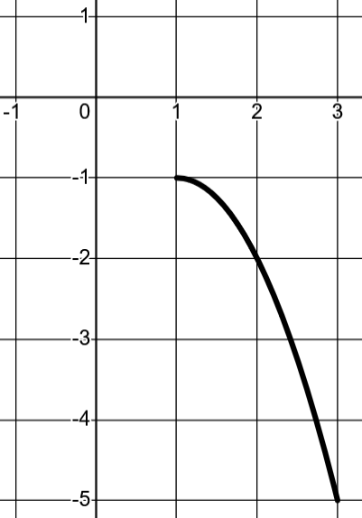
2). [P] Let $x\left(t\right)=1+\sqrt{t}$ and $y\left(t\right)=-(t+1)$.
t = 0
t = 1
t = 4
$$t$$ | $$x(t)$$ | $$y(t)$$
0 | 1 | -1
1 | 2 | -2
4 | 3 | -5

a). Here’s what the path looks like.
Something to think about: why didn’t I have you plot t = 2 or t = 3?

b). To find the cartesian equation, isolate t in one equation and substitute into the other.
Here are two ways that could look:

Version 1: Isolate t in the $x(t)$ equation  $x\left(t\right)=1+\sqrt{t}$ $x-1=\sqrt{t}$ ${\left(x-1\right)}^{2}=t$  Now substitute $t={\left(x-1\right)}^{2}$ in for t in the y equation: $y= -\left({\left(x-1\right)}^{2}+1\right)=-{\left(x-1\right)}^{2}-1$ | Version 2: Isolate t in the y$(t)$ equation  $y\left(t\right)=-(t+1)$ $y=-t-1$ $t=-y-1$  Now substitute $t=-y-1$ in for t in the x equation: $x=1+\sqrt{-y-1}$. This equation also works. Is it the same? Put it in $y=…something…$ form to check.  $x=1+\sqrt{-y-1}$ $x-1=\sqrt{-y-1}$  ${\left(x-1\right)}^{2}=-y-1$ $-y={\left(x-1\right)}^{2}+1$  $y=-{\left(x-1\right)}^{2}-1$

In this case it seems version 1 was (maybe) slightly easier. For a new problem, it’s worth thinking about both options. The domain restriction is $1≤x≤3$ since those are the only x-coordinates visited in all the times between 0 to 4.
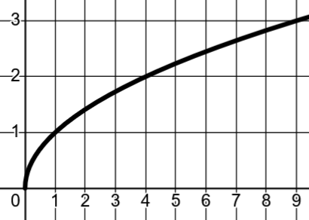
3). [C/P] Make a single x-y graph for each set of parametric equations. Make a quick table if you really need to (say, plug in t = 0, 2 and 4), but your goal is just to capture the overall shape and think more intuitively about the x and y motions separately.
(a). $x\left(t\right)=t^{2}$, $y\left(t\right)=t$ on $t≥0$
You can think of it this way: as the y-coordinates increase from 0 at a constant rate, the x-coordinates grow like a quadratic. This idea produces a shape like this.
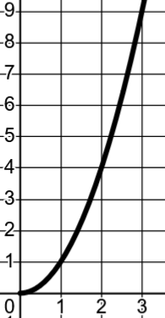
To find the cartesian equation, substitute y for t: $x=y^{2}$ and take the square root: $y=±\sqrt{x}$ . However, we know the y-coordinates are only ever 0 or larger (since $y=t$ and $t≥0$), so the actual graph is just $y=\sqrt{x}$ (without the negative branch).
(b). $x\left(t\right)=t$, $y\left(t\right)=t^{2}$ on $t≥0$
This one is opposite, in a sense. You might realize that we just swapped the role of x and y, which means this graph is the inverse of the previous one, and just reflected it around $y=x$.
Otherwise, you could substitute x for t in the $y(t)$ equation to get $y=x^{2}$. But, like last time, there’s a domain restriction. We know $x≥0$ since $x=t$ and $t≥0$. So we only have the $x≥0$ part of the parabola.


4). Consider the graphs here of $x(t)$ and $y(t)$
$$y=x(t)$$
$$y=y(t)$$
$$y-coord$$
$$x-coord$$

$$time$$
$$time$$

- These graphs are only defined for $-10≤t≤10$. If we drew the path they define on the x-y plane, what would be the domain and range of the path? Domain: $-3≤x≤7$ Range: $-7≤y≤8$

- What are the points coordinates when it reverses direction? Point reverses direction from leftward to rightward motion at t = 0 (as seen in the x(t) graph). Its coordinates at that time are (-3, 3).

- Is the point ever in quadrant IV of the plane? (remember, quadrant IV is when x is positive and y is negative). If so, when? Yes, the point has positive x coord starting at time t = 1.5 and a negative y-coordinate starting at t = 6. So it will be in quadrant 4 from t = 6.5 to 10.

- Sketch a graph of the path and motion, labelling 5 key points with their times and showing the direction of movement with arrows.
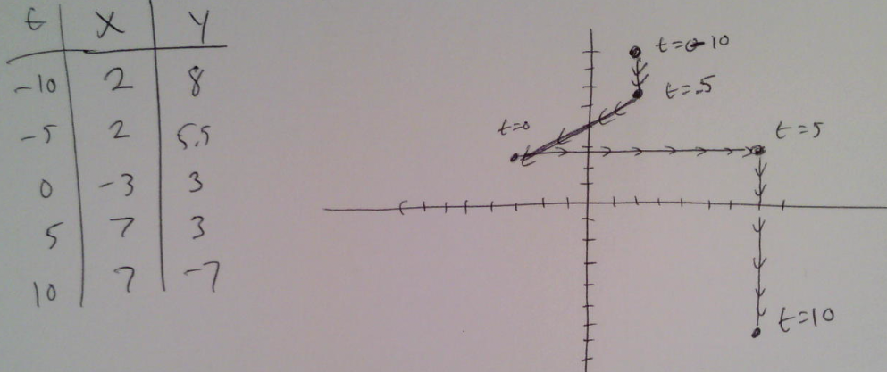

5). [C/P] Here are rough sketches for $x(t)$ and $y(t)$. Sketch the path of the motion they represent ( on the $y(x)$ graph to the right). Label the point at $t=0$ and add arrows to indicate direction of travel. ( you can think about t = 0, t = 1 and t =2 if you want).
$$x(t)$$
$$y(x)$$
$$y(t)$$



$$x$$
$$y$$
$$t$$
$$t$$
$$x$$
$$y$$
$$t=0$$




6. [C/P] Here’s a motion along a path. a). Here’s an example $x(t)$ and $y(t)$ that would produce this path and movement.
$$x(t)$$
$$y(t)$$
$$t$$
$$t$$
$$x$$
$$y$$
$$t=0$$
$$t=1$$
$$t=2$$
$$y(x)$$

You can think about it this way: As the y-coordinate decreases at a constant rate from 2 to 0, the x coordinate goes from 2 to 1 and back to 2 again in a parabolic pattern.
7). [C] Consider $x\left(t\right)=\frac{1}{t^{2}+5}$ . At time t = 0 what’s the x coordinate? Your friend thinks that as time increases, the point will be moving to the right, because $t^{2}$ is positive.
Carefully explain what’s actually happening. How could they know for themselves that was true by looking/thinking about the equation?
At $t=0$, $x\left(0\right)=\frac{1}{0^{2}+5}=\frac{1}{5}$. To figure out what’s happening with the movement, let’s plug in x =1 and x = 10. $x\left(1\right)=\frac{1}{6}$ and $x\left(10\right)=\frac{1}{105}$ . Clearly as t increases, the x coordinate is getting smaller towards 0. That implies that the point is moving left, but also slowing down (since it will never reach 0).
8). Your friend changed the time bounds of $x\left(t\right)=\frac{6}{t}+2$ and $y\left(t\right)=\sqrt{t}$ from $1≤t≤10$ to $0≤t≤30$.
Before: graph of $1≤t≤10$ | After: graph of $0≤t≤30$
 | 
They say: “woah, why did changing the time to 30 make the graph run way off to the right like that?”

They aren’t correct. If I plug in $t=30$ I get $x\left(30\right)=\frac{6}{30}+2=2+\frac{1}{5}$ . So this section comes from $t>10$.
Notice the lower bound of the time changed from 1 to 0. Maybe that’s what explains it?
If $t=\frac{1}{2}$, $x\left(\frac{1}{2}\right)=2+\frac{6}{\left(\frac{1}{2}\right)}=2+12=14$. Ah ha! You can see that when $0<t<1$ dividing by t will increase the x-coordinate. So the entire right-tail when $x>8$ happens when $0<t<1$.
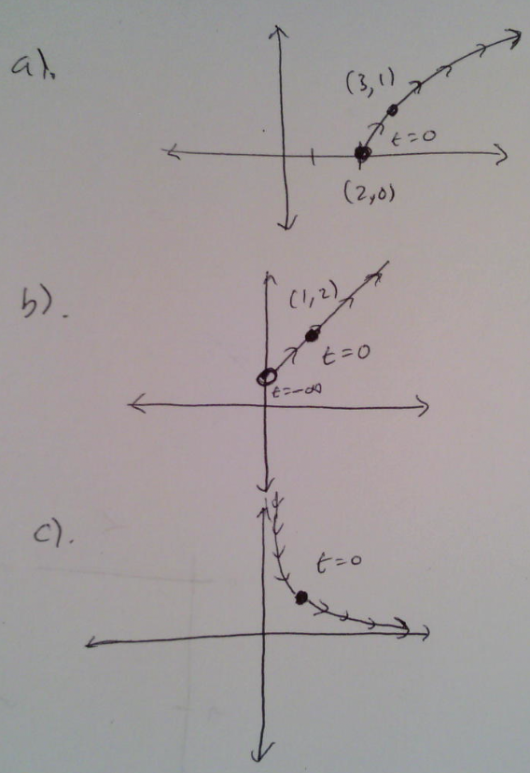
9). Sketch the curve defined by each set of parametric equations are given here. Eliminate t to find a rectangular (cartesian) equation for each path.
- $x(t)=t+2$, $y(t)=\sqrt{t}$ for $t≥0$
- $x(t)=3^{t}$, $y(t)=1+3^{t}$ for $t≥0$
- $x(t)=2^{t}$ $y(t)=\frac{1}{2^{t}}$ for $t≥0$
Rather than make tables, I’m going to find the rectangular equations FIRST and then use them to sketch. The sketches I’ve given for b and c show all times $-∞<t<∞$ with t = 0 marked.
a). $y=\sqrt{x-2}$ for $x≥2$
b). $y=1+x$ for $x>1$
c). $y=\frac{1}{x}$ for x > 1

10). [C] In part c of the last problem you should have ended with the cartesian equation $y=\frac{1}{x}$ . However, the path travelled by $x\left(t\right)=2^{t}$ and $y\left(t\right)=\frac{1}{2^{t}}$ doesn’t cover the full curve $y=\frac{1}{x}$.
a. What domain restriction on the cartesian equation exists due to the time restriction $t≥0$ ?
Think about the $x(t)$ equation. If $t≥0$ we know we’ll hit x coordinates only when t is positive. At t = 0, $x\left(0\right)=2^{0}$ which is 1. So $x≥1$.
b. If you sketched the path for $-∞<t<∞$ would there still be a domain restriction for the path? Explain.
If we let time range over all times, there is still a domain restriction. Think: could $x\left(t\right)=2^{t}$ ever be negative? Definitely not, because $2^{t}$ can’t output a value less than 0 no matter what the time is. So even if time ranges over all possible values, we still have $x≥0$ (which you see in the graph above).
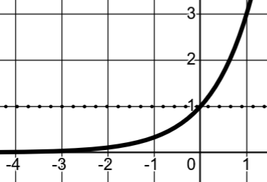
c. What about equation b? If we allow $t>-∞$ where, exactly, is the point when $-∞<t<0$ (ie for negative times) ?
$$x\left(t\right)=3^{t}$$
Equation b above is similar. If $x\left(t\right)=3^{t}$ and we want to know where the point is when t is negative, think about what $x\left(t\right)=3^{t}$ will be for negative values of t. If you imagine the graph of $x(t)$ you could see that when $t≤0$ the output is between 0 and 1. So we know that when time is negative, the x-coordinates are between 0 and 1.
Look back at the full graph for equation b above and notice where $t=-∞$ is marked and where $t=0$ is marked.
11). [P] If $x\left(t\right)=\sqrt[3]{t}-3$ and $y\left(t\right)=2^{\sqrt[3]{t}}$ represent a motion along a path, what’s the equation of the path?
Remember: you don’t need to isolate t. I see a $\sqrt[3]{t}$ in both equations, so I just need to isolate $\sqrt[3]{t}$ to substitute. $x=\sqrt[3]{t}-3$ so $x-3=\sqrt[3]{t}$. That means I can substitute x -3 for $\sqrt[3]{t}$ in the $y(t)$ equation. That gives me $y=2^{x-3}$.

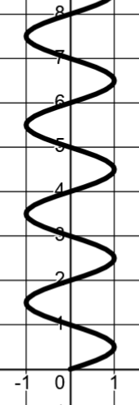
12). [C] Consider the equations $x\left(t\right)=sin(πt)$ and $y\left(t\right)=t$.
a. Sketch a graph of what this path looks like for $t≥0$
See the graph to the right.

b. Could we find a cartesian equation for this path? Could we find a function whose graph $y=f(x)$ represents the path? Explain.
The answers here are to clarify what it means to be a cartesian equation.
Since $y=t$ we can substitute in to the $x(t)$ equation to get $x=sin⁡(πy)$. This is a valid cartesian equation since it relates and x and y without the parameter t. However, it isn’t in the familiar $y=…x…$ form you may be most comfortable with.
What if we try and put it in that form? We could try and use inverse sine…
$x=\sin\left(πy\right)$ $\sin^{-1}\left(x\right)=πy$ $y=\frac{1}{π}⋅\sin^{-1}{(x)}$
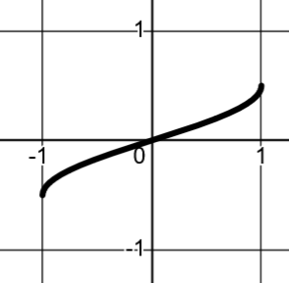
This isn’t the same thing, however, because inverse sine is a function, so it can only output one value for each input. Here’s a graph of $y=\frac{1}{π}⋅\sin^{-1}{(x)}$. It only represents the part of our graph where $-\frac{1}{2}≤y≤\frac{1}{2}$ . Briefly, the reason why is that $\sin^{-1}{(1)}$ is the angle whose sine output is 1. There are an infinite number of angles which do this: $\frac{π}{2},\frac{9π}{2},\frac{17π}{2},$ etc. Really, any full circle plus another $\frac{π}{2}$. Since inverse sine needs to be a function, it will only output the first of these: $\frac{π}{2}$. So $\sin^{-1}{(1)}=\frac{π}{2}$. If we divide that by $π$ we get $y=\frac{1}{π}⋅\left(\frac{π}{2}\right)=\frac{1}{2}$. Similarly for when $x=-1$.
So where did we end up here? We can make a cartesian equation for the path: $x=sin⁡(πy)$ but we can’t write a function for the path, because the path isn’t a function – it has multiple y-values for a single x-value (fails the vertical line test). That means we can’t actually isolate y in the equation.
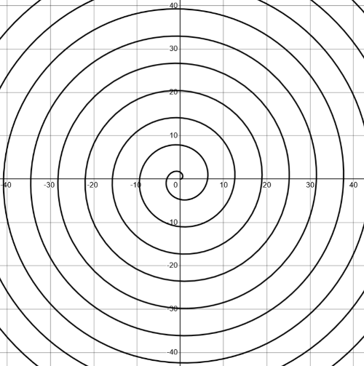
I included this problem to show you that even though you know a technique to find a cartesian equation, part of the power of parametric functions is that it’s easy to describe paths that would be difficult or impossible to express using cartesian equations.
A simple example of parametric equations that describe a simple path that’s impossible to write a cartesian equation for would be $x\left(t\right)=t⋅cos⁡(t)$ and $y\left(t\right)=t⋅sin⁡(t)$. Hopefully it’s clear why you can’t isolate and substitute for t. Other algebraic tricks for trying to eliminate t will also fail. Yet the path it describes is a simple spiral.

